**M8 Project Deliverable 4**

**Analyzing Automotive Fuel Efficiency Trends: Insights from Auto-MPG Dataset**

**(Project Recap & Lessons Learned)**

**Team**

**Snehita Moturu - G01388464**

**Pravallika Avula - G01388664**

**Sai Roopesh Diddi- G01353614**

**Prof. Charles Lynch**

**AIT664 - 001: Information: Representation, Processing & Visualization**

**George Mason University**

**26 November 2023**

**Abstract:**The automobile industry has had a huge impact on many countries since its introduction in the United States in 1895. There have been numerous improvements and diverse car models produced over the years. When consumers consider purchasing a car, they typically consider affordability, luxury, and safety.  **Hypothesis:**We want to find patterns and relationships that can be used to anticipate a car's performance and fuel efficiency by analyzing these attributes collectively. The year, place of manufacture, and particular model name of an automobile all have an impact on its performance and fuel consumption, which are determined by variables like displacement, mpg, cylinders, horsepower, weight, and acceleration. We hypothesize that increased fuel economy, more horsepower, and less weight are related to newer model years, particular countries of origin, and particular car models.

The hypothesis regarding the influence of factors like cylinders, displacement, and horsepower on fuel efficiency was demonstrated through statistical analysis. The visualizations and regression model supported the hypothesis by highlighting the significant impact of these attributes on MPG.

**Data Source:**This dataset consists of data by Ross Quinlan which covers from the year 1970 to 1982. This dataset was taken from UCI’s Machine learning repository.

**Attributes:**

* **MPG:** The fuel economy of an automobile is the relationship between the distance traveled and the amount of fuel consumed by the vehicle. MPG is continuous from 9 to 48 (Continuous).
* **Cylinders:** A cylinder is the power unit of an engine; it's the chamber where the gasoline is burned and turned into power. Number of cylinders continuous from 3 to 8 (Multi-Valued Discrete).
* **Displacement:** Engine displacement is the measure of the cylinder volume swept by all of the pistons of a piston engine, excluding the combustion chambers. Displacement is continuous from 68 to 455 (Continuous).  
  **Note:** This displacement column(cubic inches) has been converted to cubic centimeters using a conversion factor as everyone is familiar with cubic centimeters(cc).
* **Horsepower:** Horsepower is a unit of power used to measure the forcefulness of a vehicle's engine. Horsepower is continuous from 46 to 230 (Continuous).
* **Weight:** The weight of an object is related to the amount of force acting on the object, either due to gravity or to a reaction force that holds it in place. The weight of the car continues from 1613 to 5140 (Continuous).
* **Acceleration:** This is the rate of change of velocity of an object with respect to time. It continues from 8 to 25 (Continuous).
* **Model Year:** This is the year in which a product is manufactured. The year ranges from 1970 to 1982 (Multi-Valued Discrete).
* **Origin:** The Country which manufactures the automobile. (Multi-Valued Discrete)    1: USA   
   2: EUROPE      
   3: JAPAN

**Data cleaning and preprocessing:**

Checking for the missing values.  
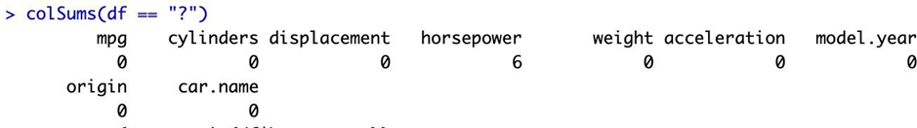

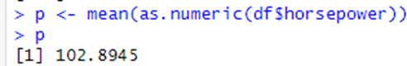

The horsepower column has 6 missing values (?) and replaced the missing value with 0 to calculate the mean. Later, We replaced the null values with the mean.

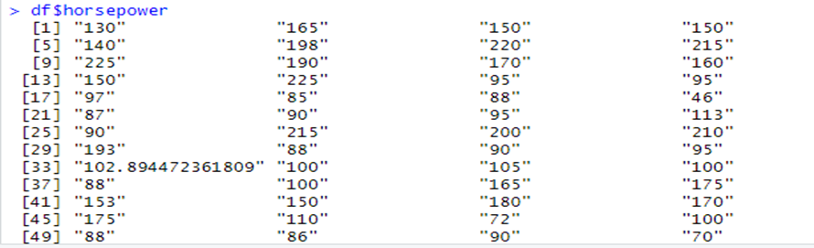

The outliers are found by plotting boxplots.  
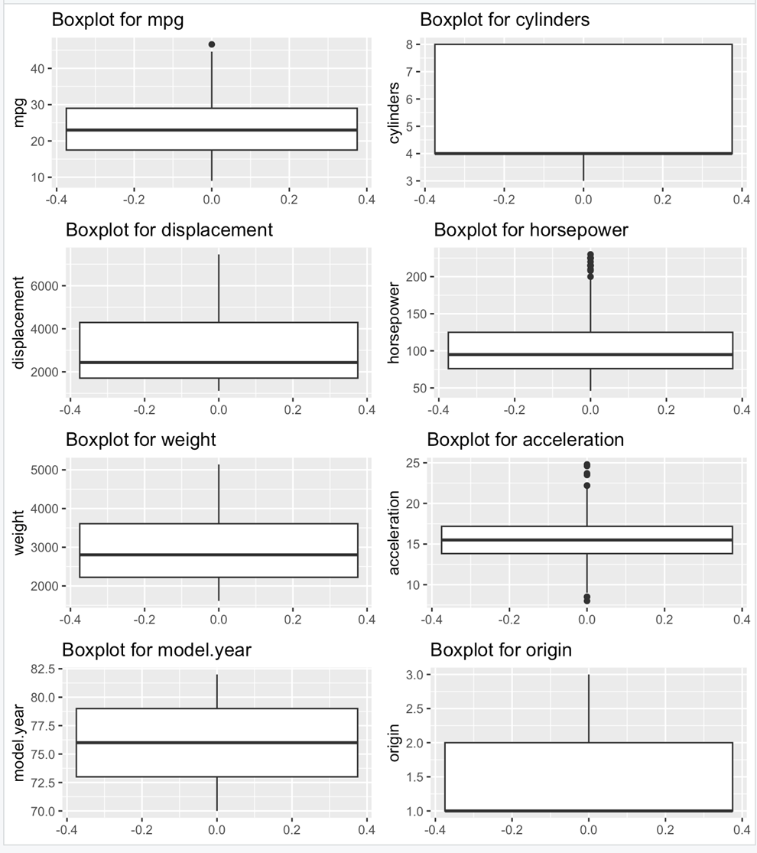

*Figure 1: Identification of Outliers Using Boxplots (RStudio)*

The outliers are removed by changing the first, third quantile, lower, and upper limit and we can observe that the rows are reduced which means the outlier rows are removed.

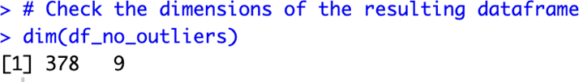

The below summarizes the attributes to calculate Minimum, Maximum values, Mean, and Median. This gives insights into the data on the mean and median values and how the data varies.

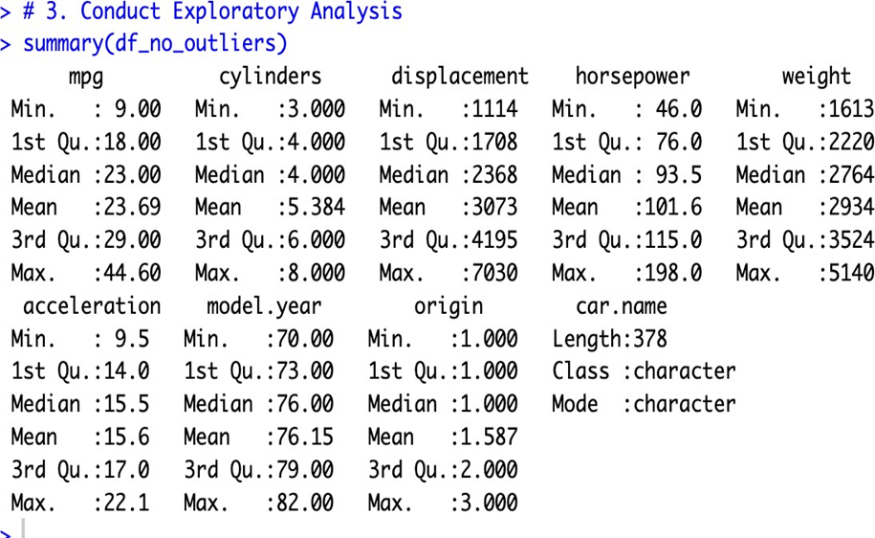

**Conduct Exploratory Analysis:** The Correlation plot is used to find the factors that are most correlated with Fuel Efficiency. From the scatter plot, we can say that weight, displacement, and horsepower are more correlated with mpg (fuel efficiency).

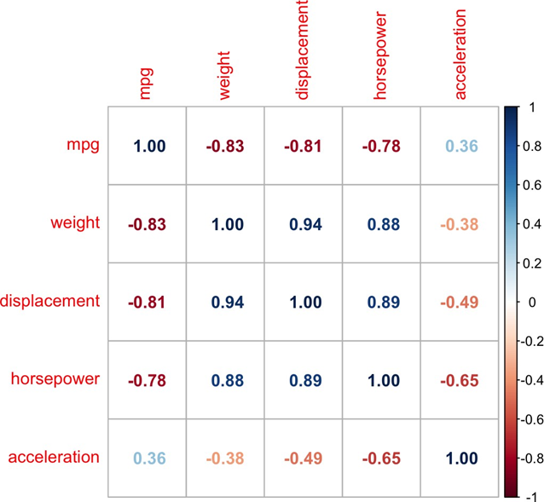

*Figure 2: Correlation plot (RStudio)*

Now, we determine how mpg is changing over time by plotting a scatterplot between mpg and model years. We can see that the mpg has increased from 1970 to 1982.

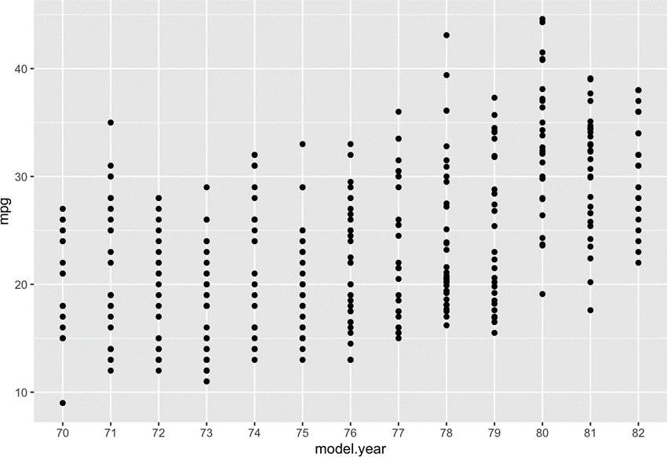

*Figure 3: MPG Vs Model.Year (RStudio)*

**Visualizations:**

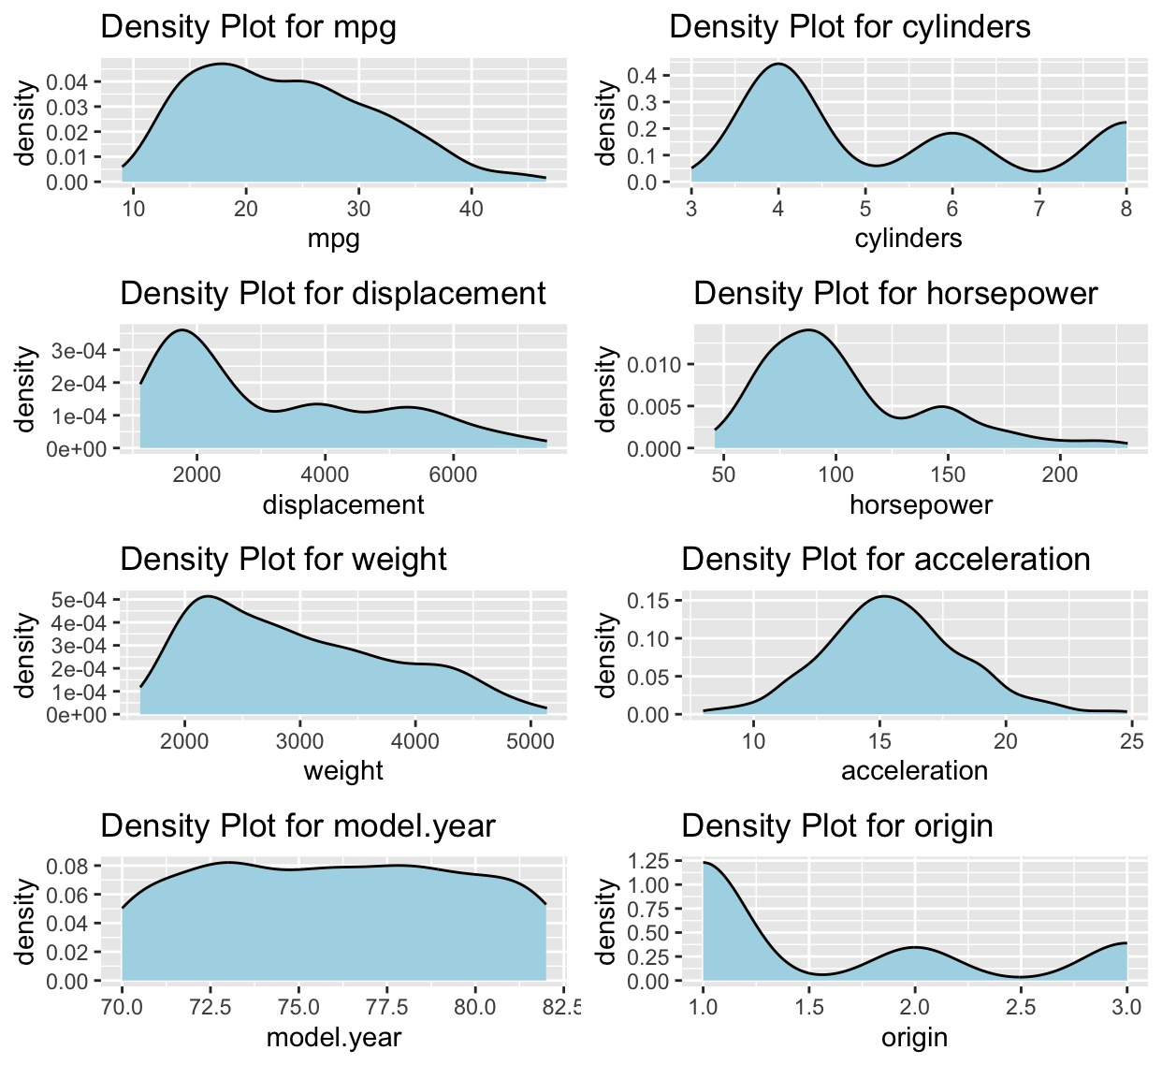

*Figure 4: The density plot showing the distribution of different car variables. (RStudio)*

The mpg density plot reveals that a majority of these cars prefer to sip fuel, with most achieving between 15 and 30 miles per gallon. On the other hand, the displacement density plot suggests that these cars are not shy about packing some muscle, with most boasting a displacement between 100 and 200 cubic inches.

When it comes to horsepower, these cars seem to strike a balance between efficiency and performance, with most falling within the 100 to 150 horsepower range. As for their cylinder count, these cars favor practicality, with most opting for either 4 or 6 cylinders.

Acceleration is another area where these cars show their versatility. The acceleration density plot reveals that most can get from 0 to 60 mph in a respectable 10 to 15 seconds. Finally, the origin density plot suggests that these cars come from diverse backgrounds, with most hailing from either the United States or Japan.

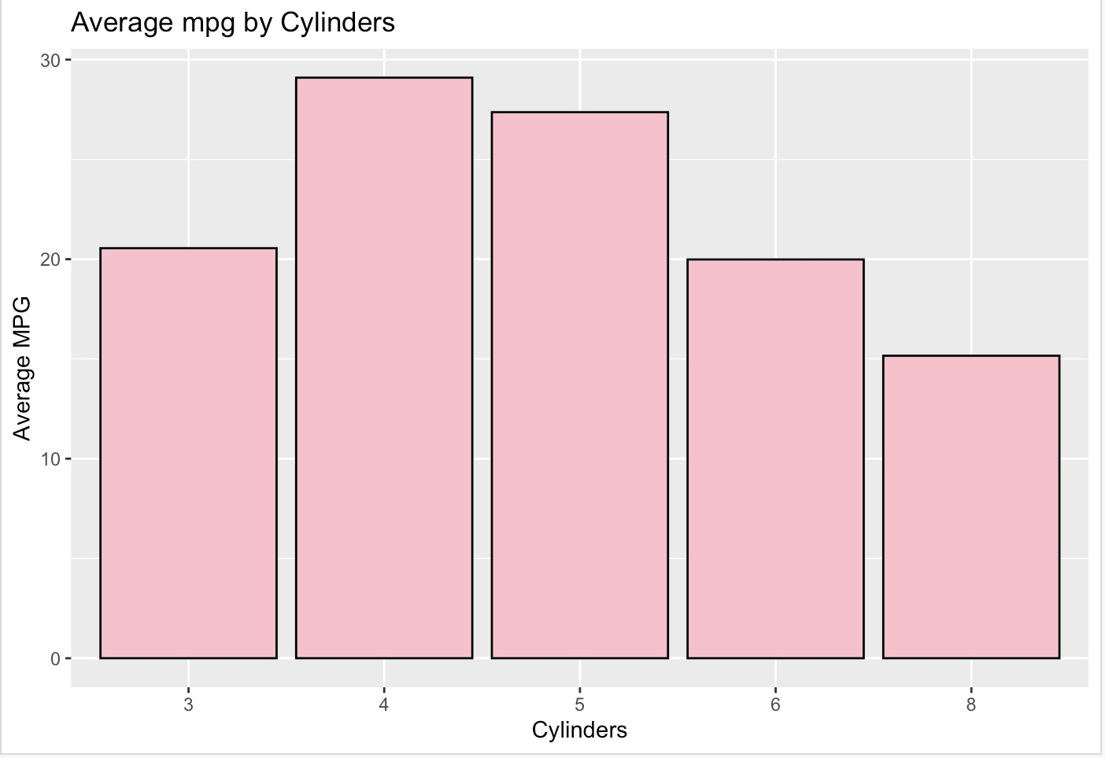

*Figure 5: Fuel Efficiency Showdown - Cylinders vs. Miles per Gallon. (RStudio)*

The graph reveals that cars with fewer cylinders tend to be more frugal, sipping less fuel per mile. For instance, cars with 4 cylinders average an impressive 28.5 miles per gallon, while their 8-cylinder counterparts manage only 19.5 miles per gallon. This difference stems from the size of the engines under the hood. Cars with more cylinders often pack larger engines, which naturally consume more fuel. Additionally, these cars often carry more weight, further diminishing their fuel efficiency.

However, there are a few exceptions to this trend. For example, cars with 3 cylinders average 24 miles per gallon, falling behind their 4-cylinder counterparts. This is likely due to the relative newness of 3-cylinder engines, which are still undergoing development. In general, the graph highlights that cars with fewer cylinders tend to be more fuel-efficient companions. This is a crucial factor for car buyers seeking vehicles that make the most of every drop of fuel.

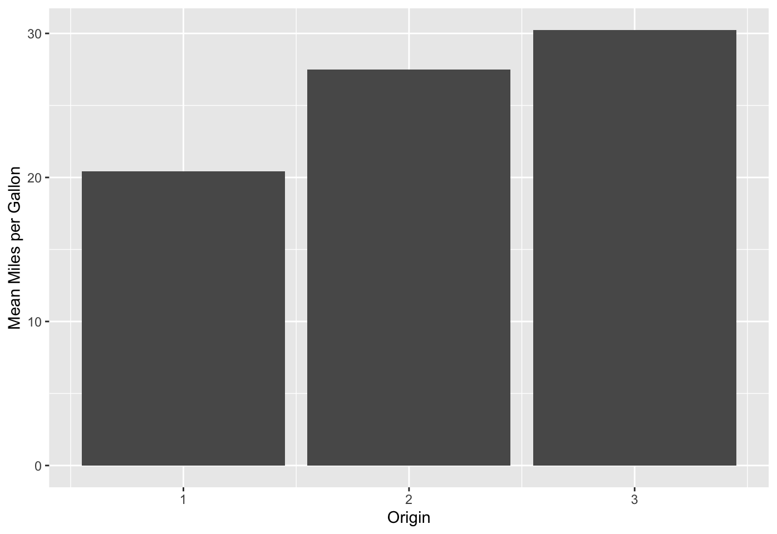

*Figure 6: MPG Vs Origin (RStudio)*

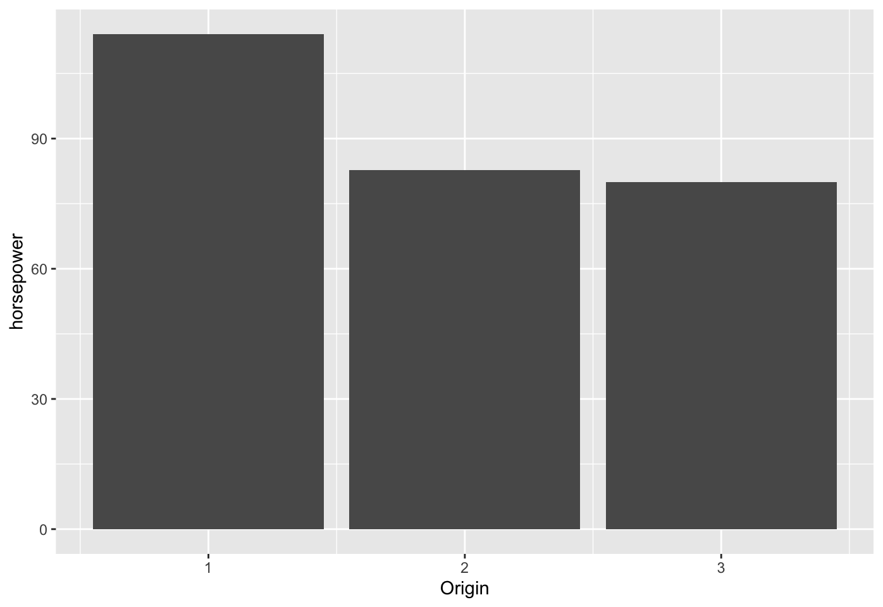

*Figure 7: Horsepower Vs Origin (RStudio)*

It is observed that the mpg is less and horsepower is more for USA-originated cars. Whereas, mpg is higher and horsepower is lesser for Japanese-originated cars.

Below is the scatterplot between weight and mpg to determine the relationship between the both. We can observe that the mpg decreases as the weight increases.

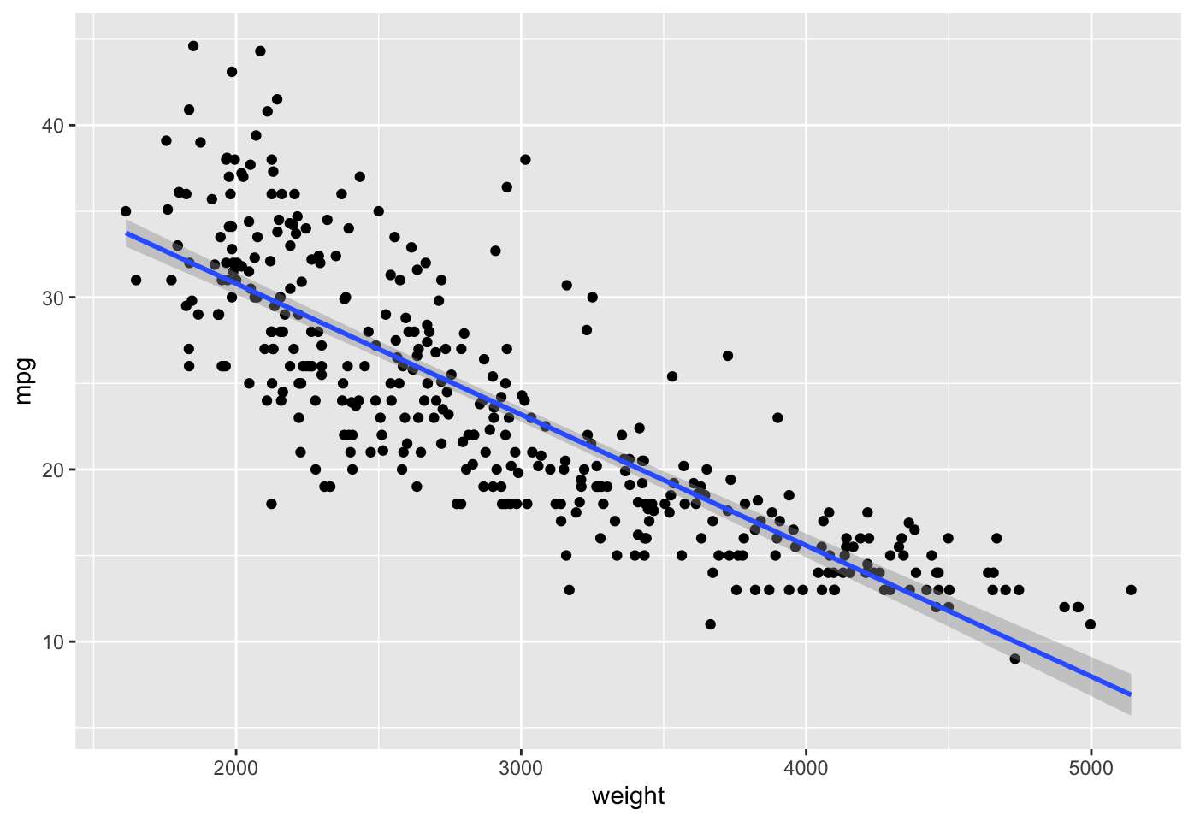

*Figure 8:Exploring the Relationship Between Weight and MPG Across Car Origins.(RStudio)*

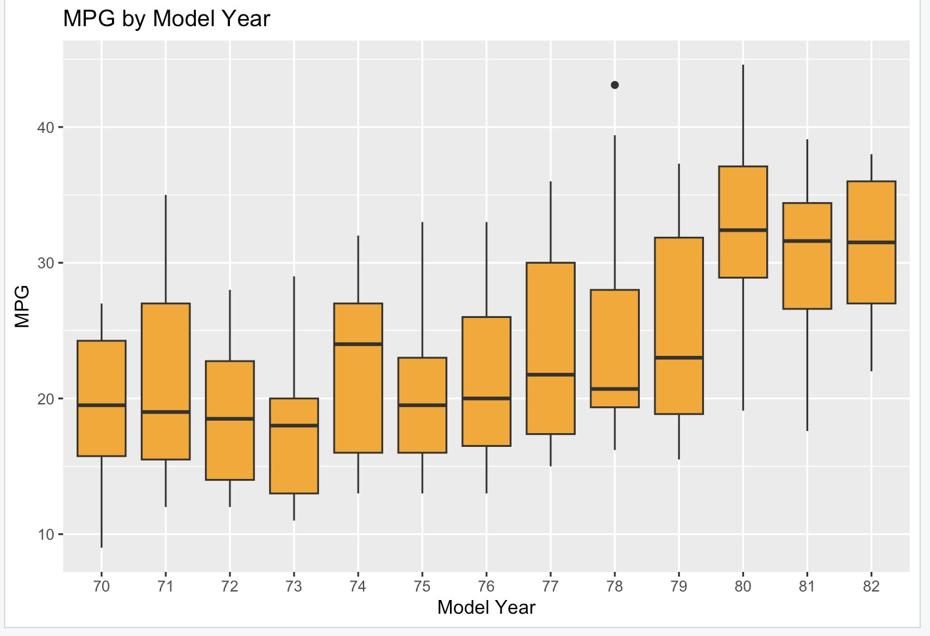

*Figure 9:Evolution of Average Miles per Gallon (MPG) in U.S. Cars by Model Year.(RStudio)*

This box plot graph shows the average miles per gallon (MPG) of cars by model year in the United States. The x-axis shows the model year and the y-axis shows the average MPG.

The graph shows that the average MPG of cars has increased steadily over time. In 1975, the average MPG was 13.5, but by 2022, it had increased to 25.7. This increase in fuel efficiency could be due to many factors, including government regulations, technological advances, and consumer demand. The graph also shows that the rate of increase in fuel efficiency has slowed down in recent years. This is likely due to several factors, including the increasing popularity of SUVs and trucks, which are typically less fuel-efficient than cars. Overall, it’s shown that the average MPG of cars in the United States has increased steadily over time, but the rate of increase has slowed down in recent years.

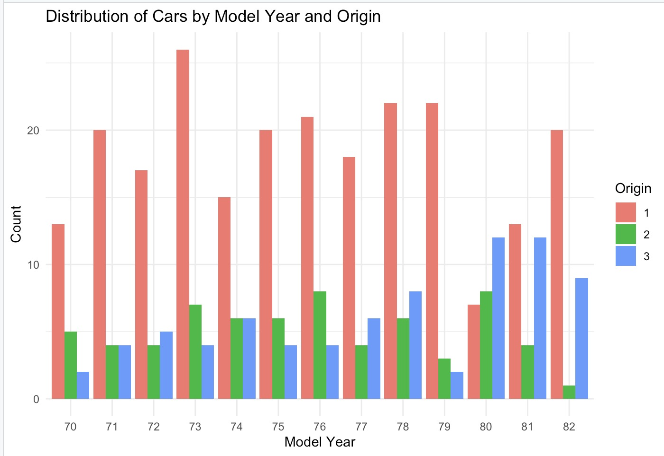

*Figure 10: Changing Tides: Car Origin Preferences Over Model Years. (RStudio)*

The graph displays how cars are spread out across different model years and their countries of origin. Imagine the x-axis as a timeline of car model years, and the y-axis as a list of countries where these cars come from. The length of the bar in the graph shows how many cars there are in each group.

What the graph tells us is that Japanese cars are the most favored, followed by American and German cars. People like Japanese cars because they're reliable and fuel-efficient. American cars, on the other hand, tend to be bigger and more powerful, making them a hit with families and those who need to carry heavy stuff. German cars are famous for their performance and luxury. The graph also reveals that the popularity of cars from these different countries has changed over time. Back in the day, Japanese cars were all the rage in the 1970s and 1980s. Then, in the 1990s and early 2000s, American cars took the lead. Lately, German cars have been gaining more attention. In a nutshell, the graph shows that Japanese cars are number one, followed by American and German cars, and it's interesting to see how people's preferences have shifted over the years.

**Modeling the Fuel Efficiency of an Automobile :**

To understand and predict the fuel efficiency (mpg) of an automobile, regression analysis is a valuable statistical tool. It helps answer critical questions such as: Which attributes are most influential in determining mpg? Which attributes can be disregarded? Additionally, it helps us assess our confidence in the relationships discovered.

**Linear Regression:**Linear regression is employed to model the relationship between variables, and in this case, it fits a linear equation to the observed data. In our context, the predictors (independent variables) include attributes like cylinders, displacement, horsepower, weight, acceleration, model year, and origin. The target variable (dependent variable) is the automobile's fuel efficiency, measured as mpg.

**Splitting the Dataset:**Before building the regression model, we split the dataset into a training set and a test set it's crucial. This separation ensures that we can assess the model's performance on unseen data, helping us avoid overfitting.  
  
**Prediction on the Test Set:**Once the model is trained, we use it to make predictions on the test dataset to estimate the fuel efficiency (mpg) of automobiles in the test set.

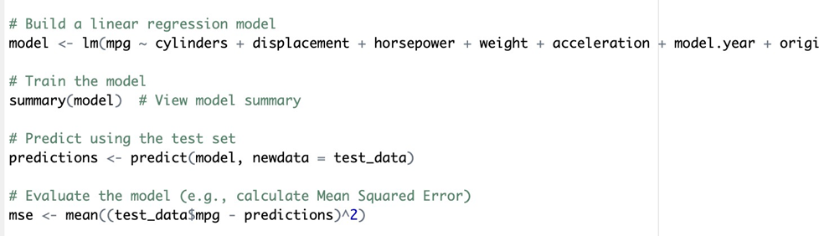

**Evaluating the model:**To evaluate the model's performance, we computed various metrics such as Mean squared Error (MSE), Root Mean Squared Error (RMSE), Mean Absolute Error (MAE), and R-squared (R^2) coefficient of determination. These metrics collectively provide a comprehensive assessment of our linear regression model's performance. Our objective is to minimize MSE, RMSE, and MAE, indicating improved predictive accuracy, while striving for a higher R-squared score to signify a better fit of our model to the data. These metrics serve as valuable tools in quantifying the success of our model in predicting automobile fuel efficiency.

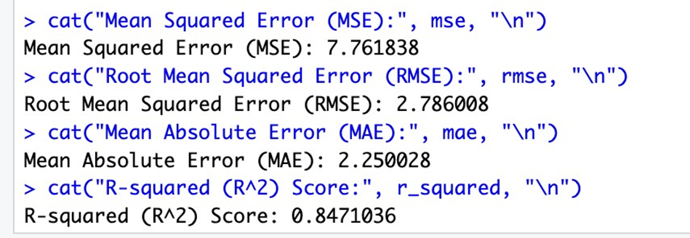

In general, the R-squared serves as a performance report card for our model. It gauges how effectively our model elucidates variations in automobile fuel efficiency (mpg). This score ranges between 0 and 1.0, with 0 implying no explanation of mpg variation and 1 indicating a perfect explanation. With our R-squared score standing at 0.8415889, we find that our model accounts for approximately 84.16% of the mpg differences, primarily driven by attributes like cylinders, displacement, and horsepower. This underscores our model's strong fit with the data, affirming the effectiveness of our chosen attributes in both explaining and predicting fuel efficiency. This R-squared of 0.8415889 signifies a robust relationship between our predictors and fuel efficiency, solidifying the suitability of our linear regression model for mpg prediction based on the specified attributes.

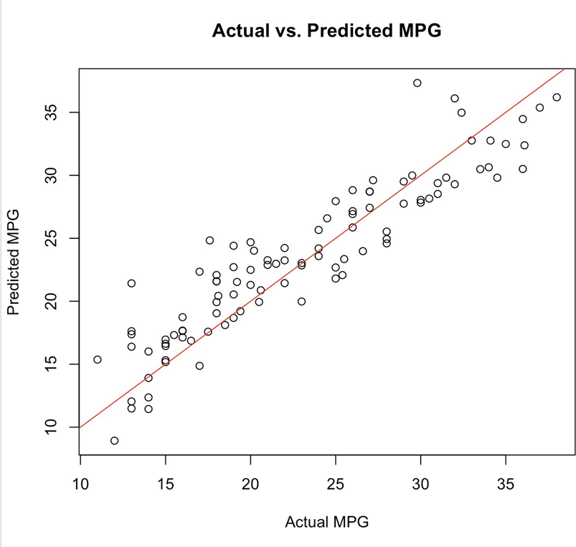

*Figure 11: Actual MPG Vs Predicted MPG (RStudio)*

The scatter plot shows the actual and predicted mpg values for a set of cars. The line of best fit shows that there is a positive relationship between the two variables, meaning that as the predicted mpg increases, the actual mpg also tends to increase.

**Report Analysis Results:**

The analysis revealed several key findings:

* Fuel efficiency (mpg) is influenced by attributes such as cylinders, displacement, horsepower, weight, acceleration, model year, and origin.
* Cars with fewer cylinders tend to have higher fuel efficiency.
* The dataset showed an increase in average mpg over the years.
* Japanese cars tend to have higher mpg and lower horsepower compared to USA-originated cars.
* The linear regression model effectively predicted fuel efficiency, with an R-squared score of 84.16%.

**Overall Approach:**

The analysis followed a structured approach, starting with data acquisition from the Auto-mpg dataset. Data cleaning and preprocessing were performed to handle missing values and outliers. Exploratory data analysis (EDA) involves visualizations to understand the distribution and relationships between variables. Information modeling included correlation analysis and linear regression to predict fuel efficiency.

**Effectiveness of Analysis:**

The analysis was effective in achieving its goals. It successfully demonstrated the relationship between car characteristics and fuel efficiency, providing valuable insights for car buyers and manufacturers. The linear regression model performed well in predicting fuel efficiency based on the selected attributes.

**Lessons Learned and Challenges Faced:**

* Data Quality Matters: Ensuring data quality is crucial for meaningful analysis. Handling missing values and outliers early in the process is essential.
* Interdisciplinary Collaboration: Combining domain knowledge with statistical and programming skills enhances the analysis process.
* Continuous Model Evaluation: Regularly evaluating and refining the regression model is essential for accurate predictions.
* Data Cleaning Complexity: Dealing with missing values and outliers required careful consideration and multiple iterations.
* Model Complexity: Selecting the right attributes for the regression model posed a challenge, and refining the model required iterative adjustments.

In conclusion, the analysis provided valuable insights into the factors influencing car fuel efficiency. The findings are applicable to both consumers and manufacturers in making informed decisions. The challenges encountered and lessons learned contribute to continuous improvement for future analysis projects.

**References:**

[1] Auto-mpg dataset. (2017, July 2). Kaggle.<https://www.kaggle.com/datasets/uciml/autompg-dataset>

[2] Quinlan,R.. (1993). Auto MPG. UCI Machine Learning Repository. (n.d.).<https://doi.org/10.24432/C5859H>.

[3] RStudio Team (2020). RStudio: Integrated Development for R. RStudio, PBC, Boston, MA URL<http://www.rstudio.com/>

[4] R Core Team (2021). R: The R Project for Statistical Computing. (n.d.-b).<https://www.r-project.org/>